SHIVAGADHI ENGLISH SCHOOL
2nd Terminal Internal Evaluation - 2082
Class: Nursery Subject : Step to Handwriting
Name: ________________________________________ Roll.No. _____
1. Trace the right curves.

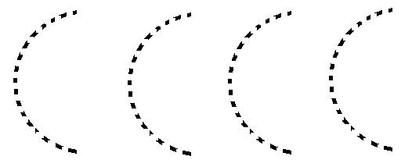

2. Trace the left curves.
